**Factory Design Pattern Concept (Layman View)**

Imagine a car company that produces cars for different regions: North America, Europe, and Asia. Each region requires different standards and specifications for cars, like the type of steering wheel (left-hand drive or right-hand drive), emission standards, and even aesthetic preferences.

In the Abstract Factory pattern, you would have a separate factory for each region - let's call them *NorthAmericaCarFactory*, *EuropeCarFactory*, and *AsiaCarFactory*. Each of these factories knows how to produce cars that meet the specific requirements of their respective regions.

When the car company receives an order, it doesn't manually assemble every car with region-specific parts. Instead, it uses the appropriate regional factory, which automatically uses the right standards and parts for that region. For example:

- **NorthAmericaCarFactory** creates cars with left-hand steering, specific emission standards, and styles preferred in North America.

- **EuropeCarFactory** makes cars with right-hand or left-hand steering depending on the country, adheres to European emission standards, and follows European design aesthetics.

- **AsiaCarFactory** builds cars suited for Asian markets, considering local regulations and preferences.

This way, the car company (the client in our analogy) does not need to worry about the specifics of each region's standards. It simply requests a car from the appropriate factory, and the factory handles all the details. This pattern allows for:

1. **Modularity**: Each factory encapsulates the knowledge of how to produce cars for a specific region.

2. **Scalability**: The company can easily add a new factory for a new region without changing the existing factories or the client code.

3. **Flexibility**: It's easy to switch production from one region to another by just using a different factory, without modifying the core logic of the car company.

**UML Components**

1. **CarFactory** **(AbstractFactory):** An interface with methods like ***createSedan()***, ***createSUV()***, which are the abstract products in this context.
2. **NorthAmericaCarFactory**, **EuropeCarFactory**, **AsiaCarFactory** **(ConcreteFactories):** These classes implement the CarFactory interface and produce cars specific to their regions, like **NorthAmericaSedan**, **EuropeSUV**, etc.
3. **Car (AbstractProduct):** This could be an abstract class or interface with different types like Sedan, SUV.
4. **NorthAmericaSedan, EuropeSedan, AsiaSedan (ConcreteProductA):** Concrete implementations of the Sedan type for different regions.
5. **NorthAmericaSUV, EuropeSUV, AsiaSUV (ConcreteProductB):** Concrete implementations of the SUV type for different regions.
6. **Client:** The part of the application that interacts with the CarFactory.

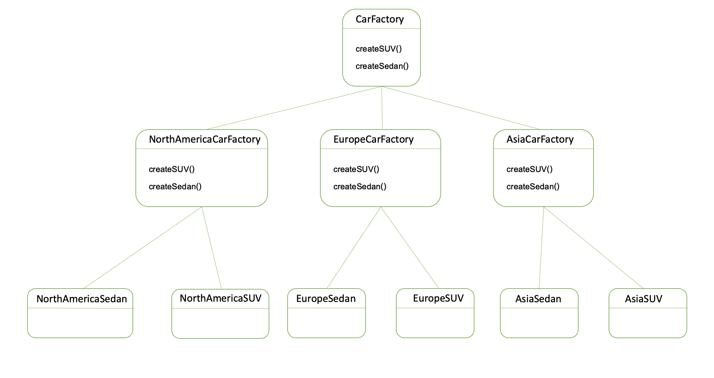

**Code Example (Client Side)**

public class CarClient {

private CarFactory carFactory;

// Constructor that accepts a CarFactory

public CarClient(CarFactory carFactory) {

this.carFactory = carFactory;

}

public void buildCar() {

// Creating a Sedan

Car sedan = carFactory.createSedan();

sedan.drive();

// Creating an SUV

Car suv = carFactory.createSUV();

suv.drive();

}

public static void main(String[] args) {

// Depending on the region, assign the appropriate factory

CarFactory factory;

String region = "NorthAmerica"; // This could be determined dynamically

if ("NorthAmerica".equals(region)) {

factory = new NorthAmericaCarFactory();

} else if ("Europe".equals(region)) {

factory = new EuropeCarFactory();

} else {

factory = new AsiaCarFactory();

}

CarClient client = new CarClient(factory);

client.buildCar();

}

}

**Pitfalls**

**Complexity:** The pattern can add considerable complexity to your code. Multiple layers of interfaces and classes can make the system harder to understand and debug.

**Maintainability**: If new kinds of factories or products are added frequently, the pattern can lead to an explosion of classes, as each new product requires a new concrete class to be created for all the concrete factories.

**Flexibility vs. Overhead**: While the pattern provides flexibility, it also introduces overhead. Sometimes, the effort of setting up the abstract factories and products is not worth the flexibility it provides, especially if the products or families of products do not change over time.

**Refactoring Challenges**: If you need to add a new variant of a product (a new method to all factories), you will have to change all existing factory classes and the AbstractFactory interface, which can be a lot of work and can break existing client code.

**Indirection:** The pattern introduces an additional level of indirection when instantiating objects, which can complicate debugging and can lead to performance overhead.

**Dependency Injection Conflicts:** In modern software development, dependency injection frameworks often provide a better way of constructing complex object graphs. The Abstract Factory pattern might conflict or be redundant with such frameworks.

**Abstract Factory vs. Factory Method:** Sometimes, it can be overkill to use an Abstract Factory when a simpler Factory Method would suffice. Overuse of Abstract Factory where not needed can lead to unnecessary complexity.

**Unit Testing:** While the pattern can be good for unit testing because it allows you to replace implementations with mocks or stubs, it can also make it harder to write tests because you need to instantiate the whole product family.

